Voyager FLEET INSIGHT
Voyager FLEET INSIGHT is a web-based application. It is accessible from anywhere via a standard web browser from any device including desktop computer, laptop or tablet. There is also a lite version, “VFI Go”, for use on smartphone plus a wallboard version for display on large screens in offices.

Vessel information at your fingertips
Once logged into Voyager FLEET INSIGHT, a whole world of information is opened up to the user to help make ship management, navigation and compliance management and purchasing related tasks simpler, more efficient and more cost-effective.
Know more. Guess less. Boost productivity.
Voyager FLEET INSIGHT’s home page provides an overview of the customer’s fleet at any time. Vessel positions are updated up to every 10 minutes and key vessel characteristics such as IMO number, Class, Flag, sailing hours, last port call and AIS destination are all available at a glance. Vessel position is provided using a mix of terrestrial and satellite data to provide a higher level of accuracy.

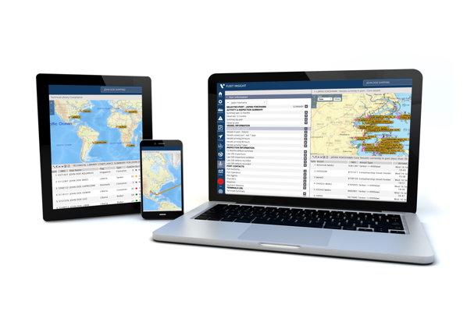  Voyager FLEET INSIGHT works on PC, tablet, smartphone and even has a wallboard mode. |  | 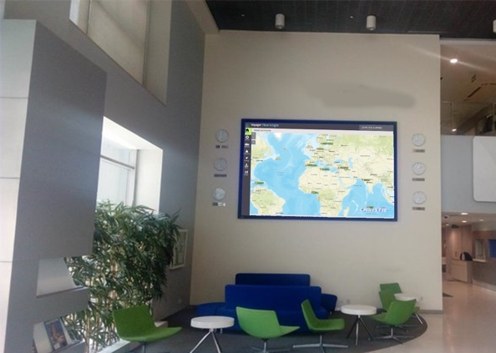

Voyager TV
Voyager’s Wallboard module enables shore-based offices to display fleet movements in real-time on large screen. The service shows a picture of the vessels while following their position, speed, movement, ETA, etc.
Importantly, just like the rest of Voyager FLEET INSIGHT, the Wallboard module works using a standard internet browser. There is no requirement to download or install any software.

Compliance with SMS requirements
Today, many Safety Management Systems (SMS) require vessels’ passage plans to be sent to shore for approval, but how do you ensure ship management has sufficient information to approve the route? Likewise, how can the shore-based team monitor the vessel against the approved route and in the event of an emergency or other vessel-related incident, how do you ensure that shore-based teams have similar situational awareness as the ship?
Whether it be checking and approving passage plans against official ENCs, providing navigational advice to vessels, monitoring vessels’ progress against approved routes or dealing with vessel-related incidents from shore, Voyager FLEET INSIGHT puts all the information you need at your fingertips.

Checking and approving routes
Voyager FLEET INSIGHT offers shore-based managers an easy way to check and approve planned routes in accordance with their SMS procedures. Vessel’s planned routes are automatically uploaded and displayed. Route can be displayed on top of CMAP charts or official AVCS ENCs and overlaid with other key compliance and security information such as MARPOL zones, latest weather conditions from DTN SPOS and piracy incidents from Risk Intelligence. Routes can then be carefully vetted and inspected to identify any safety or compliance issues and approved before they begin.
Users are able to ensure that areas being transited are considered in advance when compiling detailed passage plans with the aid of critical information relating to sensitive sea areas, MARPOL zones and detailed forecasted weather fronts including surface and wind conditions.
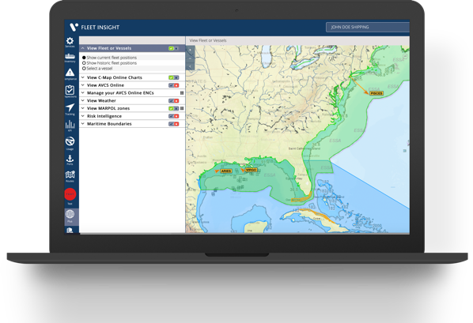  Voyager FLEET INSIGHT supports SMS requirements and enhances shore based situational awareness. |  | 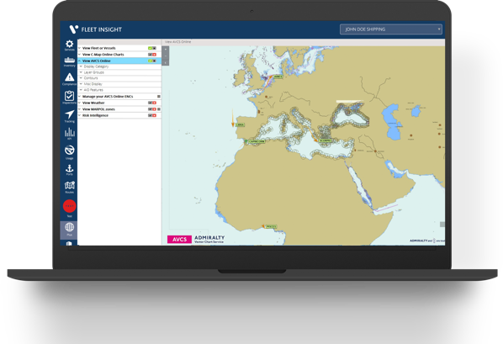

Online access to official AVCS ENCS
Importantly, Voyager FLEET INSIGHT users can benefit from web-based access to AVCS official Electronic Navigational Charts (ENCs) and the Admiralty Information Overlay (AIO) for route checking and approval. AVCS is the world’s leading ENC service, offering the widest coverage in the marketplace. With access to more than 16,000 ENCs of all scales, the AVCS Online module allows Managers and Superintendents to check and approve an unparalleled number of international shipping routes and make navigational decisions with unrivalled confidence.

Digital safety checks on board to save time ashore
Onboard, Voyager PLANNING STATION’s Route Validation tool allows vessels to run digital safety checks on routes before sending plans to shore for approval. That means plans are less likely to have issues and makes shore-based approval both simpler and more efficient.

Port Information module
From December 2020, a new Port Information module will provide access to the I.H.S Ports and Terminals database as well as the ability to view vessels that are in a specific port.

Vessel tracking and management
Throughout the vessel’s voyage, managers and superintendents are able to view their vessel position in relation to the planned route overlaid on the official ENC chart together with weather, areas that may be susceptible to an increased risk of piracy and areas of significant importance in relation to environmental control and management, in order to safeguard the asset and protect human life.
Voyager FLEET INSIGHT’s tracking module also provides a more detailed and historic view of vessel movements. Using the Tracking module, ship management can see the track taken by individual vessels for periods of the last 24 hours up to the last 12 months and as far back as 2015.
The tracking module also shows the port calls at a fleet level and which ports each vessel has visited in the last 12 months which can be useful for budgeting and planning purposes as well as the amount of time the vessel has spent at each port. Nautical Miles sailed, percentage of time spent at sea also provide useful data for monitoring vessel ‘yield’, support operations budget preparation and justify increasing (or decreasing) operational expenditure.

Navigational safety and compliance
Every year, navigation related compliance issues account for more than 7000 Port State Control inspection failures globally. It is one of the most common reasons for a vessel being non-compliant, receiving a fine and or being held in port.
With Voyager, both the navigator on board and ship management on shore also have full visibility of the ENCs and digital publications required for each vessel’s intended voyage, together the full list of products the vessel holds and whether they have been corrected to reflect all recent updates or changes. This helps ensure that any intended voyage is always carried out with the latest ENCs and digital publications.

Technical library management
Voyager FLEET INSIGHT’s Compliance module tracks the status of each vessel’s publication inventory against the very latest SOLAS requirements by Flag and Class to provide ship management with a full view of compliance requirements by Flag and Class for all vessels they manage. As a result, any gaps in holdings can be easily identified and addressed to help avoid PSC and vetting issues.
Voyager FLEET INSIGHT holds up to three lists of publications:
- Minimum Flag Mandated which is a list of the publications that are defined by the vessels Flag as being the minimum required for compliance
- The Voyager Worldwide Essentials list which takes into account the wider regulatory environment beyond just the Flag State and for example incorporates publications specified for ship communications and, for tankers, OCIMF’s (Oil Companies International Marine Forum) Ship Inspection Report Programme (SIRE).
- The customer’s own defined publications library which is generally preferred by most big fleets.
A simple traffic light system shows whether all the publications in each category are a) present and b) the right edition. The user can then drill down into the data and see exactly the status and the cost of bringing the library up to the standard required to avoid potential inspection issues. Compliance requirements and the status of each vessel’s inventory are constantly updated as regulations change, New Editions are published and purchases are made.
You can choose to have relevant New Edition publications automatically supplied or to self-manage compliance by ordering New Editions as required.

Efficient order management
Voyager FLEET INSIGHT’s order management module enables users to control purchasing more effectively. When a vessel places an order for digital or paper navigation supplies, an email alert is sent to the designated budget holder/approver ashore so that the order can be checked, approved, amended or declined.
As soon as an order has been approved, permits for digital orders are automatically supplied to the vessel and paper supplies are scheduled for despatch in accordance with the vessel’s despatch schedule.
Details of vessels orders are displayed together with details of the vessel’s intended route to make it easier for ship management to identify erroneous purchases and reduce unnecessary spending.

Inspection histories
The Voyager FLEET INSIGHT’s Inspections module enables ship management to view the PSC inspection histories for their fleet to help track compliance performance and more easily identify compliance issues that may need to be addressed.
Inspection data can also be viewed by port to enable managers to see which ports are most likely to inspect their vessels to ensure that vessels are adequately prepared.

Key performance indicators (KPIs)
The KPIs module provides an example of the possibilities of using Voyager FLEET INSIGHT data to manage key areas of fleet performance. Information collected by Voyager Worldwide systems is shown in graphical format to make it easier to compare vessels and identify outliers.
As at today, we are providing KPI information about the following:
- Expenditure on digital navigation
- Usage of digital navigational products
- Sailing distances
- Percentage sailing time
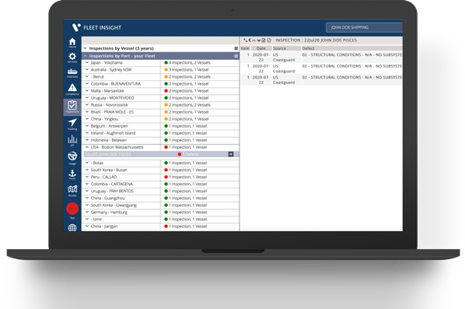  Voyager FLEET INSIGHT helps you to keep track of compliance and spending. |  | 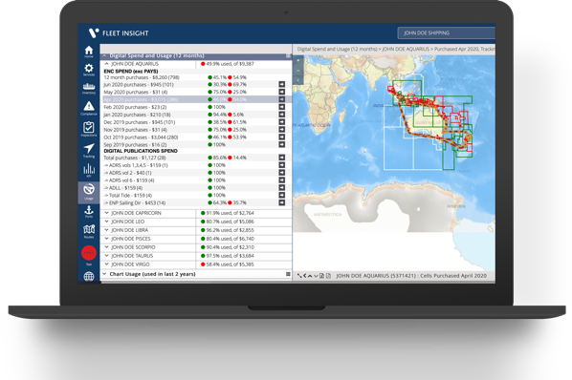

Usage analysis
The Usage module provides information about how efficiently vessels are buying navigational supplies. Voyager Worldwide data shows that the majority of vessels overspend on navigation for a variety of reasons including:
- Purchasing too far in advance and then receiving changes of orders.
- Auto-renewing digital publication licences and ENC permits that are no longer relevant.
- Purchasing ‘just in case’ in the same way that paper charts have been purchased in the past.
The Usage module in Voyager FLEET INSIGHT enables ship management to identify where overspending is occurring and to work with vessels to buy more efficiently. It can also provide a good indicator of whether a company should consider switching to PAYS or continue to use conventional purchasing methods.
The module tracks ENC spend against actual vessel routes and shows this information both on a map and in tabular format.

Reports
Voyager FLEET INSIGHT’s Reports module enables ship management to extract information about their fleet in a variety of ways. You can choose from a set of pre-created reports under “Voyager Worldwide Reports” or to create your own reports from any number of the 150 data fields stored within Voyager FLEET INSIGHT. Reports can be exported as PDF or excel for further analysis and for use in other ship management systems.

Get started straight away
Unlike some competitor shore-based applications, there isn’t any software to install. Once your account has been set up, all you need in order to use Voyager FLEET INSIGHT is your email address and a password.
User access to Voyager FLEET INSIGHT is controlled using customers’ personal user IDs and is very flexible. For example: you can choose who in your organisation should have access to Order Approvals and give different users within the company the ability to view different sub-fleets of vessels if required.

Voyager PLANNING STATION
Voyager PLANNING STATION provides an easy to use and cost-effective solution for the complex and time-consuming task of managing electronic and traditional navigation onboard.
Having everything required to manage digital and paper navigation and passage planning in one place means navigators don’t have to keep switching between different software for different tasks and provides a much simpler and more efficient way of working.

Simple installation
The Voyager PLANNING STATION software is supplied on a pre-loaded USB device that also includes AVCS, ADP and AeNPs, Witherby e-Book reader and a set of Technical publications to meet the customer’s requirements. When inserted into a ship’s computer, an installation wizard installs everything that is required very quickly and easily.
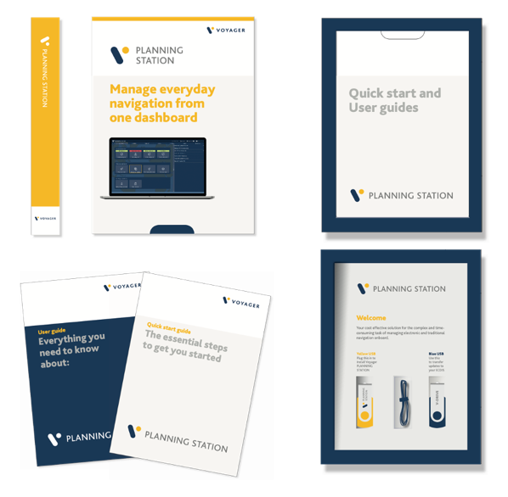  Voyager PLANNING STATION provides a complete navigation solution. |  | 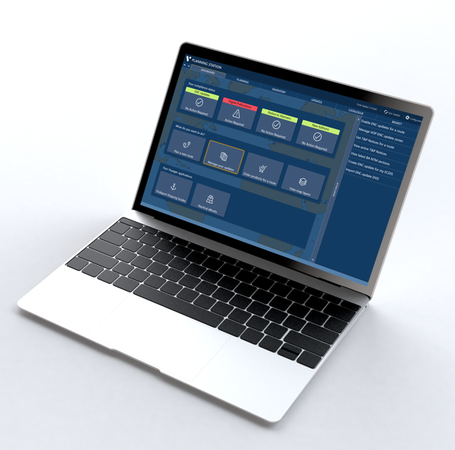

Easier route planning
Voyager’s route planning module enables navigators to plan routes on a marine map or using official ENCs or to import a route from a file. From the dashboard, users simply select Plan a Route to open easy to follow step by step instructions.
In addition, an inbuilt “port to port” routeing service enables the navigator to enter two points and automatically generate a route to make route planning even faster.
Once the route is generated, it can be displayed with all required e-Navigation information incorporated as overlays on top of the latest updated ENCs.
Layers include the Admiralty Information Overlay (AIO), ADP, AENP, Navarea Warnings, MARPOL areas, port data and maritime security. These layers of information can be switched on or off depending on the navigator’s requirements to help refine route decisions.
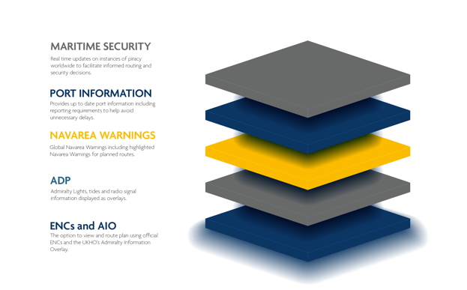  Layers of navigational information help the navigator to refine route decisions. |  | 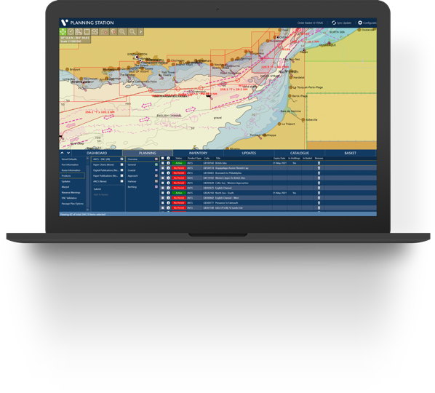

Weather routeing and optimisation
Voyager works with StormGeo BVS, Meteo Group SPOS and WNI Capt.’s Dosca weather routeing software to enable navigators to optimise planned routes based on parameters such as fuel efficiency and target arrival time.

Voyager Route Validation
Voyager PLANNING STATION includes the option to run digital safety checks between each waypoint to analyse the route and compare the navigational data with the vessel’s draught, height and other specifications.
Validating routes before transferring to ECDIS reduces the risk of the ECDIS route validation failing and streamlines the route and passage planning process prior to the start of a voyage. This feature requires Voyager’s ENC Viewer to be enabled and for the relevant ENC permits for the route to be purchased and installed.

Passage Plan documentation
The Passage Plan module in Voyager uses digital technology to reduce the paperwork and administration relating to planning upcoming voyages. The tool simplifies and enhances the task of creating safe, compliant and accurate passage plan documentation. ENC cells, ADP, AENP, T&P, NavArea Warnings, UKC calculations and MARPOL are automatically logged and in the Voyager passage plan template for each waypoint. The result is a much faster, easier passage plan document to meet PSC and vetting requirements.

Route-based ordering
Once the navigating officer has planned the route, Voyager automatically and precisely identifies all the digital and paper navigational products required to sail safely and compliantly. The navigator can view Voyager’s product recommendations on the map or in a list, add or remove items and order those required to make navigational compliance for a voyage simpler and easier.
Digital and paper navigational products can also be ordered at any time using Voyager’s up to date navigational product catalogue.

Instant access to Digital Products
Customers can choose to give vessels instant access to digital products via Voyager’s Instant Permit module. Voyager Instant Permit enables the permits for the ENCs and digital publications (ADP and AeNP) that vessels order to be automatically received on board - usually within 10 minutes of an order being sent.
Ship Management set the order limit they are comfortable with and the Voyager Worldwide system only auto-supplies permits for orders up to that limit. When orders exceed that limit, Ship management is alerted by email so they can log in to Voyager FLEET INSIGHT to approve, amend or, if required, decline the order.

Digital and paper updating
Voyager PLANNING STATION offers both digital and paper updating via a single platform ensuring that all vessels are kept up to date and comply with Port State Control and Vetting.
Customers can choose from two updating options:
- Automatic updating which downloads updates as soon as they are available and ensures the latest information is always available onboard.
- E-mail based updating where the vessel requests updates on demand. A maximum email size can be set and updates sent in small parcels.
Voyager handles all AVCS updates and New Editions remotely. There is no need for any physical AVCS CDs or DVDs to be sent to the vessel. A digital version of the paper NTM booklet as well as Annual and Cumulative Notices also removes the need for the paper version to be sent to the vessel.

V-Drive makes ECDIS updating simple
V-Drive provides a very simple way to manage AVCS updates. Navigating officers simply plug the V-Drive into a USB port on their Voyager PC to automatically download and transfer all necessary ENCs, updates, permits and the Route file, required to navigate safely and compliantly to the V-Drive so that it can uploaded in the ECDIS.
For more secure updating, the V-Drive is automatically reformatted every time it is plugged into the Voyager PC to remove any existing content and help prevent the transfer of malware to the ECDIS.

Other navigation updates
Voyager provides a comprehensive updating service that also includes other HO (national) chart NtMs and tracings ensuring that all information required can be accessed onboard. National update options are:
- USA
- Japan
- Canada
- Australia
- New Zealand
- South Korea

New Edition and subscription management
With Voyager, navigators use the same user-friendly software platform to manage all their navigation management tasks including AVCS charts, digital publication subscriptions and paper chart and publication inventories.
Users are automatically notified when digital subscriptions are expiring so that they can be renewed in a timely way. Likewise, when New Editions of paper charts and publications in the vessel’s inventory are published, the vessel is also alerted to make it easier to maintain compliance.

Additional emergency back-up to ECDIS
Voyager’s GPS Overlay feature enables the Voyager PC onboard to be used as an extra back up to ECDIS. It works by connecting to either a wired or wireless AIS Pilot Plug or USB to NMEA device to provide the live vessel GPS position which is then overlaid on the latest ENCs in Voyager’s ENC viewer.

e-book access
For easier access, users of the Witherby and IMO eBooks can open publications from a button on the Voyager home page.

