Voyager PLANNING STATION
Voyager PLANNING STATION provides an easy to use and cost-effective solution for the complex and time-consuming task of managing electronic and traditional navigation onboard.
Having everything required to manage digital and paper navigation and passage planning in one place means navigators don’t have to keep switching between different software for different tasks and provides a much simpler and more efficient way of working.

Simple installation
The Voyager PLANNING STATION software is supplied on a pre-loaded USB device that also includes AVCS, ADP and AeNPs, Witherby e-Book reader and a set of Technical publications to meet the customer’s requirements. When inserted into a ship’s computer, an installation wizard installs everything that is required very quickly and easily.
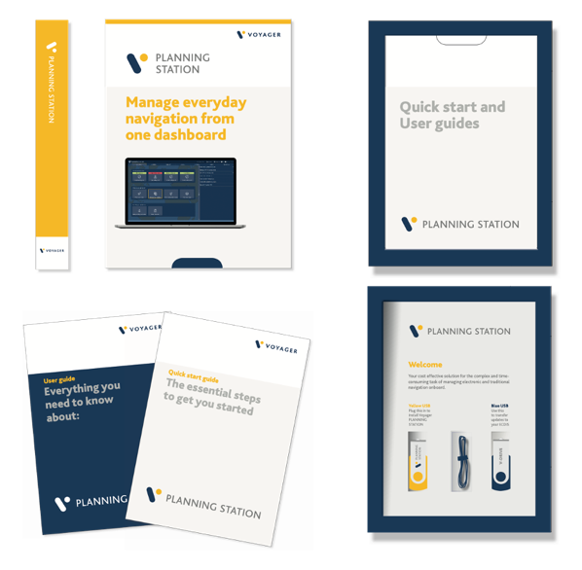  Voyager PLANNING STATION provides a complete navigation solution. |  | 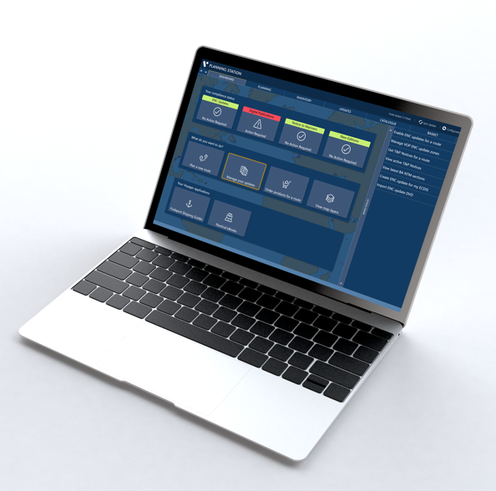

Easier route planning
Voyager’s route planning module enables navigators to plan routes on a marine map or using official ENCs or to import a route from a file. From the dashboard, users simply select Plan a Route to open easy to follow step by step instructions.
In addition, an inbuilt “port to port” routeing service enables the navigator to enter two points and automatically generate a route to make route planning even faster.
Once the route is generated, it can be displayed with all required e-Navigation information incorporated as overlays on top of the latest updated ENCs.
Layers include the Admiralty Information Overlay (AIO), ADP, AENP, Navarea Warnings, MARPOL areas, port data and maritime security. These layers of information can be switched on or off depending on the navigator’s requirements to help refine route decisions.
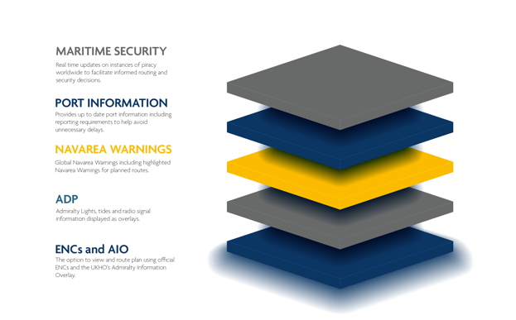  Layers of navigational information help the navigator to refine route decisions. |  | 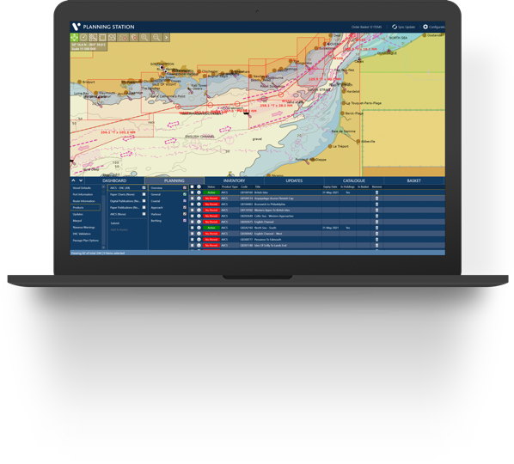

Weather routeing and optimisation
Voyager works with StormGeo BVS, Meteo Group SPOS and WNI Capt.’s Dosca weather routeing software to enable navigators to optimise planned routes based on parameters such as fuel efficiency and target arrival time.

Voyager Route Validation
Voyager PLANNING STATION includes the option to run digital safety checks between each waypoint to analyse the route and compare the navigational data with the vessel’s draught, height and other specifications.
Validating routes before transferring to ECDIS reduces the risk of the ECDIS route validation failing and streamlines the route and passage planning process prior to the start of a voyage. This feature requires Voyager’s ENC Viewer to be enabled and for the relevant ENC permits for the route to be purchased and installed.

Passage Plan documentation
The Passage Plan module in Voyager uses digital technology to reduce the paperwork and administration relating to planning upcoming voyages. The tool simplifies and enhances the task of creating safe, compliant and accurate passage plan documentation. ENC cells, ADP, AENP, T&P, NavArea Warnings, UKC calculations and MARPOL are automatically logged and in the Voyager passage plan template for each waypoint. The result is a much faster, easier passage plan document to meet PSC and vetting requirements.

Route-based ordering
Once the navigating officer has planned the route, Voyager automatically and precisely identifies all the digital and paper navigational products required to sail safely and compliantly. The navigator can view Voyager’s product recommendations on the map or in a list, add or remove items and order those required to make navigational compliance for a voyage simpler and easier.
Digital and paper navigational products can also be ordered at any time using Voyager’s up to date navigational product catalogue.

Instant access to Digital Products
Customers can choose to give vessels instant access to digital products via Voyager’s Instant Permit module. Voyager Instant Permit enables the permits for the ENCs and digital publications (ADP and AeNP) that vessels order to be automatically received on board - usually within 10 minutes of an order being sent.
Ship Management set the order limit they are comfortable with and the Voyager Worldwide system only auto-supplies permits for orders up to that limit. When orders exceed that limit, Ship management is alerted by email so they can log in to Voyager FLEET INSIGHT to approve, amend or, if required, decline the order.

Digital and paper updating
Voyager PLANNING STATION offers both digital and paper updating via a single platform ensuring that all vessels are kept up to date and comply with Port State Control and Vetting.
Customers can choose from two updating options:
- Automatic updating which downloads updates as soon as they are available and ensures the latest information is always available onboard.
- E-mail based updating where the vessel requests updates on demand. A maximum email size can be set and updates sent in small parcels.
Voyager handles all AVCS updates and New Editions remotely. There is no need for any physical AVCS CDs or DVDs to be sent to the vessel. A digital version of the paper NTM booklet as well as Annual and Cumulative Notices also removes the need for the paper version to be sent to the vessel.

V-Drive makes ECDIS updating simple
V-Drive provides a very simple way to manage AVCS updates. Navigating officers simply plug the V-Drive into a USB port on their Voyager PC to automatically download and transfer all necessary ENCs, updates, permits and the Route file, required to navigate safely and compliantly to the V-Drive so that it can uploaded in the ECDIS.
For more secure updating, the V-Drive is automatically reformatted every time it is plugged into the Voyager PC to remove any existing content and help prevent the transfer of malware to the ECDIS.

Other navigation updates
Voyager provides a comprehensive updating service that also includes other HO (national) chart NtMs and tracings ensuring that all information required can be accessed onboard. National update options are:
- USA
- Japan
- Canada
- Australia
- New Zealand
- South Korea

New Edition and subscription management
With Voyager, navigators use the same user-friendly software platform to manage all their navigation management tasks including AVCS charts, digital publication subscriptions and paper chart and publication inventories.
Users are automatically notified when digital subscriptions are expiring so that they can be renewed in a timely way. Likewise, when New Editions of paper charts and publications in the vessel’s inventory are published, the vessel is also alerted to make it easier to maintain compliance.

Additional emergency back-up to ECDIS
Voyager’s GPS Overlay feature enables the Voyager PC onboard to be used as an extra back up to ECDIS. It works by connecting to either a wired or wireless AIS Pilot Plug or USB to NMEA device to provide the live vessel GPS position which is then overlaid on the latest ENCs in Voyager’s ENC viewer.

e-book access
For easier access, users of the Witherby and IMO eBooks can open publications from a button on the Voyager home page.

